ROUND 2: DEMAND ASSESSMENT
LETTER OF INTENT FORM (NOT BINDING)
SECTION 1: YOUR CURRENT ENTERPRISES
Name of customer: ................................................................................................................................................
Company / trading name: ......................................................................................................................................
Main property / address: .......................................................................................................................................

Email: ..................................................................................... Ph/Mob: ................................................................
Q1: Do you own land in the study area to which water could viably be supplied (see map)? YES / NO
Please provide a summary of your current main enterprises or farming activities / crops below.
Q2: What do you currently produce in the proposed scheme area (average year)?
Top 5 activities (e.g. crop / enterprise) | Average annual hectares grown (ha) | Average annual crop yield (tons / ha) | Gross revenue ($/ha) | Variable input costs ($/ha) | Fixed costs ($/ha) | Approx. profit per hectare ($/ha)
Example: Dryland peanuts | 100 ha | 2.5 | $2,500 | $800 | $200 | $1,500
Example: Beef cattle | 100 head | 400kg/head | $2,000/head | $600/head | $200/head | $1,200/head
Total (ha) | ………… | N/A | ………… | ………… | ………… | …………
Q3: If you are not a primary producer please explain your current operations / enterprise here (e.g. stock and domestic, urban water supplier, flower nursery, service station, X local business):
……………………………………………………………………………............................................................................
……………………………………………………………………………............................................................................

CONFIDENTIALITY
Your commercial enterprise information, and areas and values and individual water demand volumes will be kept confidential. However, results from all customers will be summarised in our detailed business case report.

SECTION 2: NEW INFORMATION ABOUT COALSTOUN LAKES WATER PROJECT
Capital cost – Customer capital price (once-off upfront)
Customers pay a one-off capital contribution in stages for a tradable water asset and share of scheme. We ask for your demand at the capital price for Medium Priority = $2,500/ML and High Priority = $4,500/ML.
Operating cost – Annual water charges (no government subsidy available)
Governments require 100% of operating costs to be covered by annual charges. The following annual charges are draft only and may change after Round 2 demand is known and more engineering has been completed.

Water product and price summary
The proposed project is expected to acquire a mix of up to 45,000 ML of two water products from Paradise Dam
Product | Monthly reliability | Customer capital price (upfront one-off) | Fixed annual charge | Variable annual charge | Total annual charge | Volume for sale
Medium priority | 90% | $2,500/ML | $140/ML | $120/ML | $260/ML | Up to 38,000 ML
High priority | 99% | $4,500/ML | $200/ML | $120/ML | $320/ML | Up to 7,000 ML
Scheme design
The proposal is for a 180-day delivery scheme with access to water 330 days per year and 24 hours per day.
Pressure: Minimum pressure is 7 PSI. But typical pressure for most customers will be about 44 PSI.
At farm outlet | PSI | KPA | Bar | What can you run off this pressure?
Minimum guaranteed pressure | 7 | 50 | 0.5 | Flow into on-farm storage, require a pump for any irrigation
Typical pressure (80% of customers) | 44 | 300 | 3 | Direct medium pressure sprinkler (center pivot) & drip irrigation
Maximum flow rate: You can take all your water in 180 days (6 months). Your maximum flow rate is calculated as the volume you purchased divided by 180 days assuming water use 24 hours per day.
Flow rate | Demand (ML) | Max flow rate (ML/day) | Max flow rate (Litres/second) – No rostering | Updated Max flow rate (Litres/second) - with rostering
Very high | 500 | 2.78 | 32.2 | 96
High | 180 | 1.00 | 11.6 | 35
Medium | 100 | 0.56 | 6.4 | 19
Low | 50 | 0.28 | 3.2 | 10
Very low | 20 | 0.11 | 1.3 | 4
See KBR’s Round 2 demand assessment PowerPoint presentation for more detail on scheme design. This will be emailed to all participants in the project. Please ensure you have recorded an email address with the project.

Draft scheme layout based on Round 1 Demand

- Mainline is Paradise Dam via Didcot to Coalstoun Lakes
- West wing to Byrnestown
- East wing to Biggenden.

Figure 1: Engineering layout of Coalstoun Lakes Water scheme based on Round 1 demand

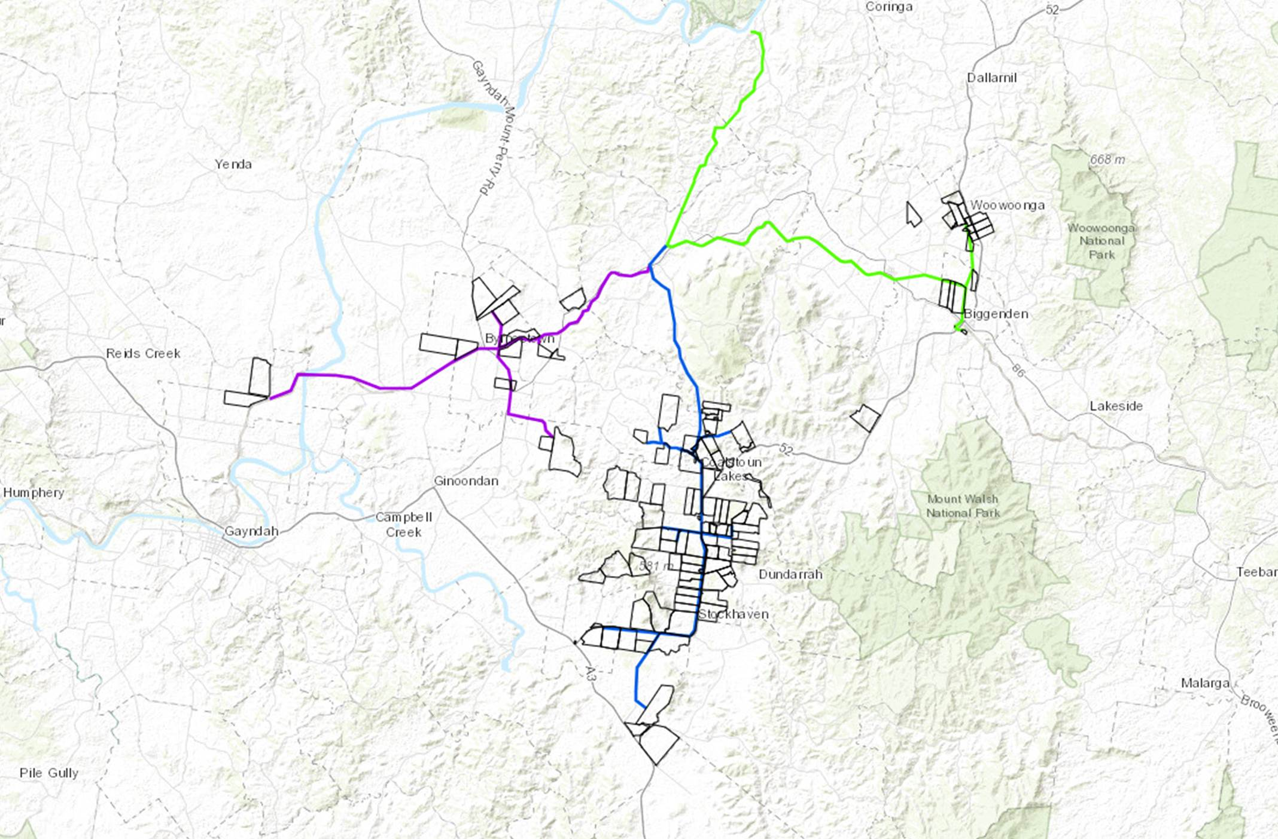

Source: Pinion Advisory using Jacobs GIS.

Figure 2: Project timelines (aspirational)
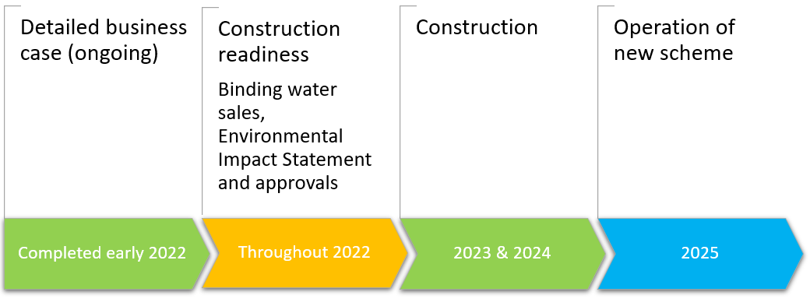

Source: KBR analysis.

SECTION 3: YOUR DEMAND FOR NEW WATER FROM THE PROJECT
Please provide an estimate of your demand for water from the project in three parts for each water product:
a) Minimum volume to be financially viable; b) Likely volume; and c) Maximum volume in a growth scenario.
Please provide lot and plan number for each block where water is to be delivered to assist with detailed design.

Q4: What is your total demand for each new water product from the project?
 | Reliability | Capital price | Annual charge | Minimum demand (ML) | Likely demand (ML) | Maximum demand (ML)
Medium priority | 90% | $2,500/ML | $260/ML
High priority | 99% | $4,500/ML | $320/ML
Total
Engineering and costs will be based on minimum or likely volumes of demand, so please be accurate with both.
Q5: What is the lot and plan number and demand volume for each block where water is to be delivered?
Scheme design will be based on lot and plan numbers as some addresses are not specific to one block.
Lot and plan number for each block where water is to be delivered | Minimum demand (ML) | Likely demand (ML) | Maximum demand (ML) | Physical address (number / street or road name / suburb)
Example: Lot 3 / RP86452 | 20 | 500 | 5,000 | 469 Flagstone Creek Road, Lilydale
Total (all properties combined)
SECTION 4: FUTURE PLANS FOR USING NEW WATER
Please provide information about your future irrigation plans so that we can estimate the direct economic benefit of this project and obtain government grant funding. How would you use new water from this project?
Q6: What are your main proposed uses for the new water?
Enterprise/s | Hectares to be planted (ha) | Irrigation water applied (ML/ha) | Average annual irrigated crop yield per hectare (t/ha) | Revenue per hectare ($/ha) | Variable input costs ($/ha) | Fixed costs per hectare ($/ha) | Profit per hectare ($/ha)
Example: Peanuts (contractor machinery) | 100 ha | 5 | 8 | $8,000 | $2,000 | $1,500 | $4,500
Total | ………… | …………. | N/A | ………… | ………… | ………… | …………
Q7: If you are not a farmer, please explain your proposed use of the new water: ..…………………………………...
……………………………………………………………………………...........................................................................
SECTION 5: UNDERSTANDING YOUR LAND AND WHAT AREA MAY BE FOR SALE OR LEASE
If you are a local landowner (see map provided above):
Q8: What total area of farming land do you own / lease (incl. for livestock) in local scheme area? (ha) …...………
Q9: What area of your land could be used for irrigated agriculture now or in the future? (ha) ……..….………….
Q10: Your answers below will help determine if external investors will be able to secure access to land.
 | What area of land would you lease? (ha) | What area of land would you sell? (ha) | What is the value of your land without this project? | What is the value of your land with this project (with reliable water)?
Example | 200 ha | 100 ha | $2,000 to $3,000/acre | $6,000/acre
Minimum
Likely
Maximum
Q11: Comment: ….……………………......……………….…………………………………………………….……………
.……………………......……………….…………………………………………………….………………………………….
SECTION 6: LAND ACCESS, CERTAINTY OF INVESTMENT AND NEXT STEPS
Land access
Coalstoun Lakes Water Ltd will not undertake to make land available to investors. Individual investors are responsible for securing land access, for example, via negotiations held in good faith with willing sellers.
- Existing landowners: If you own land in the area you are in a strong position to support this project. You need only to provided lot and plan details for each block to which you would like to see water delivered.
- Land access for external investors: If you do not have access to land in the scheme area, in Round 1 demand assessment 20 landowners in Coalstoun Lakes confidentially expressed potential interest in selling or leasing part of their land if market conditions are favourable. Landholders identified approximately 1,100 hectares that may be up for private negotiations. This data is subject to change.
Certainty of investment
Q12: To what extent are you likely to invest in the Coalstoun Lakes Water project? Please tick one box.
Likelihood | 100% Certain (5) | Very likely (4) | Likely (3) | Undecided (2) | Not Likely (1)
Your response
Q13: In 2022, if the project proceeds, are you willing to participate in Round 3: Water Sales? YES / NO
Q14: Did you attend a presentation or meeting with the KBR project team? YES / NO
Q15: NEW QUESTION - What flow rates would you require to run your irrigation equipment? (e.g.Centre Pivot)
Desired flow rate | Minimum (litres/second) | Likely (litres/second) | Maximum (litres/second)
Example | 40 | 60 | 80
Your response
YOUR SIGNATURE (NON-BINDING COMMITMENT)

Your signature: …….……………………………………….……...………..…Date: .………………...…….…………….
Use of data
- Your responses are critical to decisions about whether this project will proceed to construction.
- Responding does not imply that the project will proceed and is not legally binding on you or CLW Ltd.
- However, indications of strong demand will demonstrate significant support for the project.
Project contacts
Angus MacDonald, Study Lead & Commercial Advisor, KBR on mobile 0488 444 973 or via his email below.
Garry Seabrook, Chairman, Coalstoun Lakes Water on 0499 089 909 or email gseabrook87@gmail.com
Steve Brown, Client Project Manager on 0421 951 929 or email steve.brown@verterra.com.au
Next steps
Please print, complete and sign this form. Or fill out in Word and type your name at the signature line.
Please email back to angus.macdonald@kbr.com (this will be treated as commercial in confidential).
Due date: Close of business Thursday, 30 September 2021.

